Indefinite Integral
Hossein Rahimzadeh
www.cafeplanck.com
info@cafeplanck.com

Type1
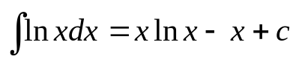
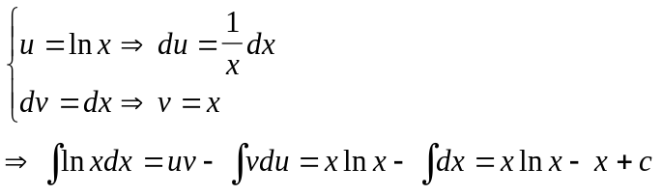

Type 2
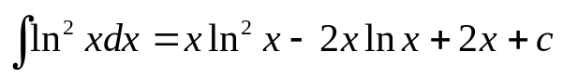
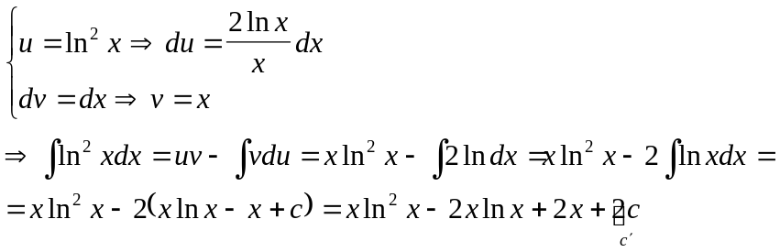

Type 3
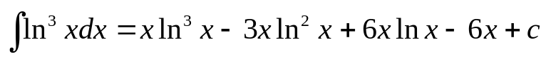
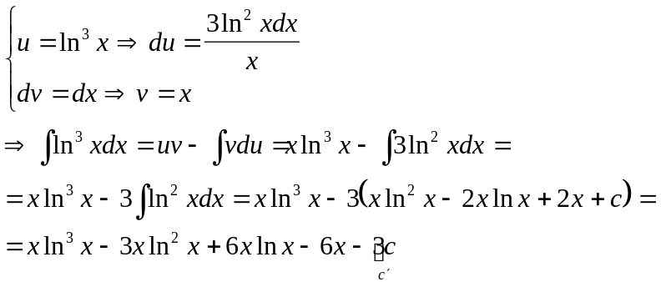

Type 4
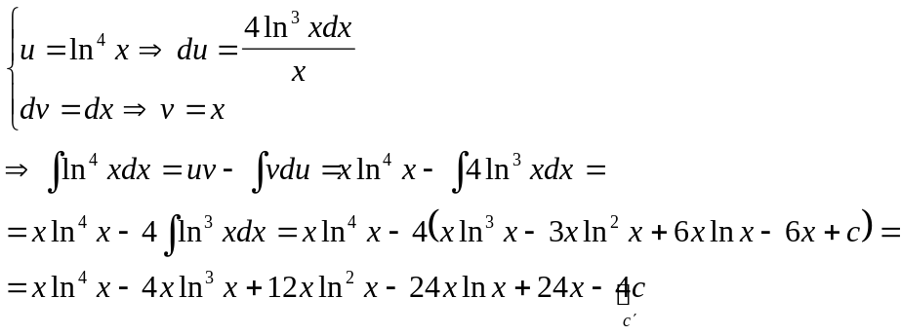

Type 5
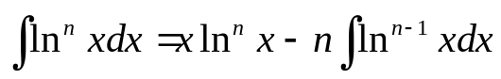
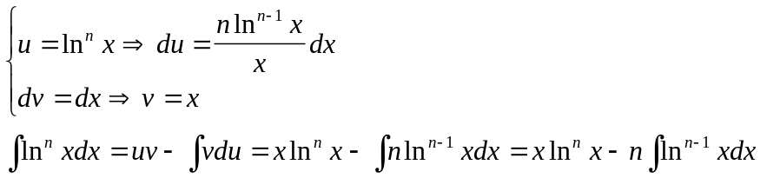

Examples
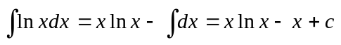
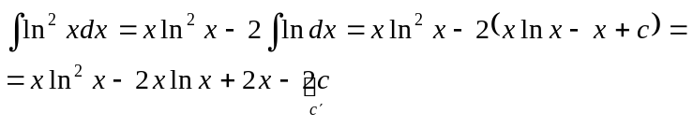
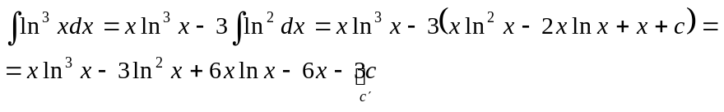
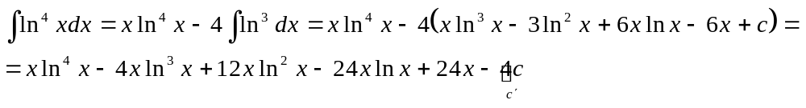

Type 6
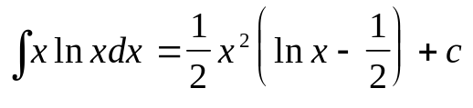
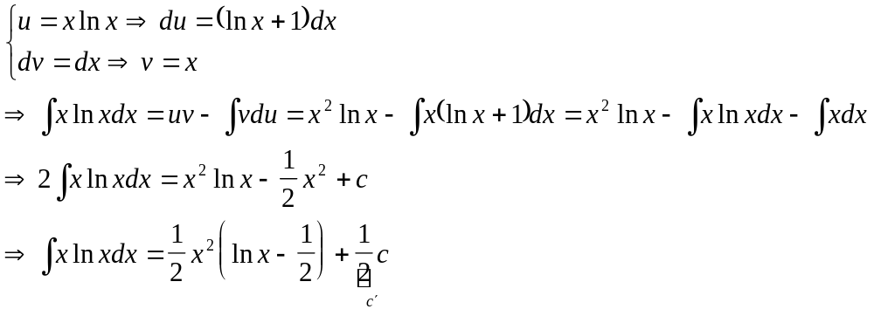

Type 7
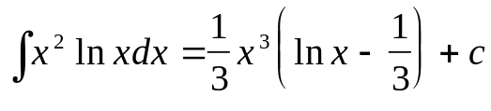
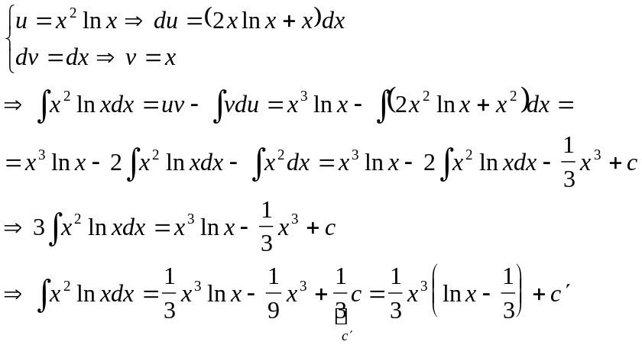

Type 8
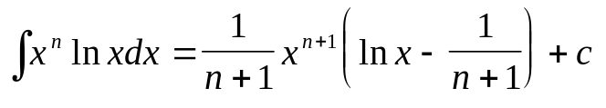
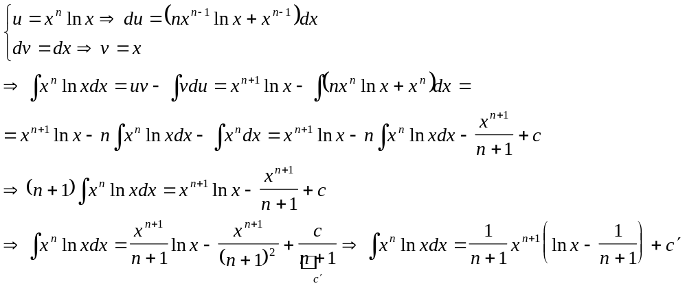

Examples
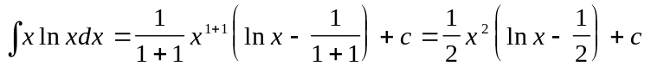
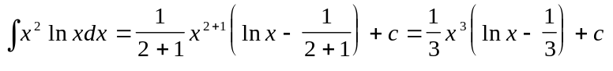
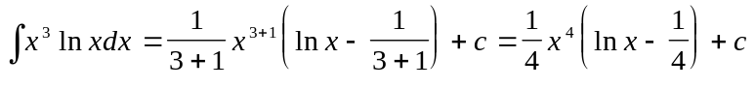
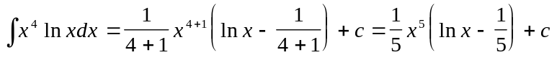

Type 9
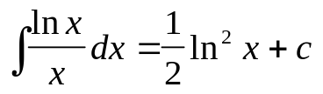
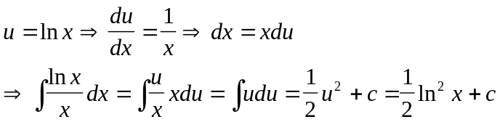

Type 10
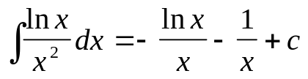
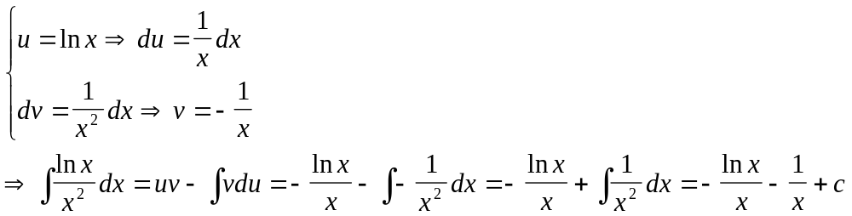

Type 11
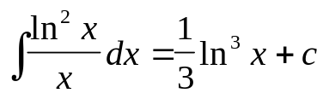
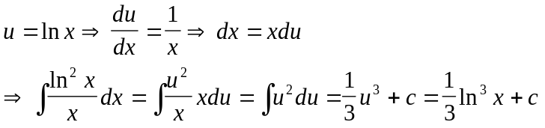

Type 12
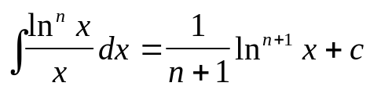
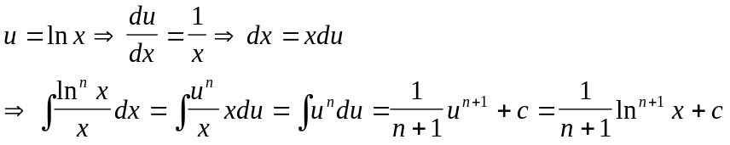

Examples
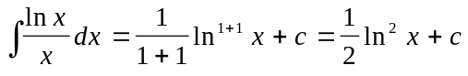
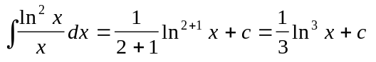
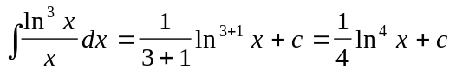

Type 13
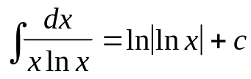
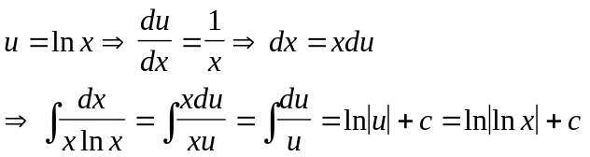

Type 14
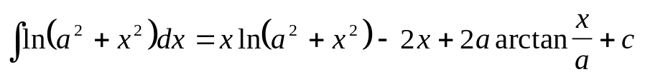
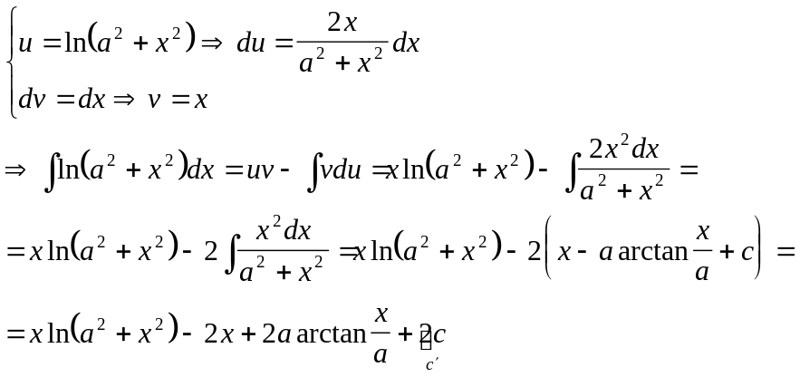

Type 15
